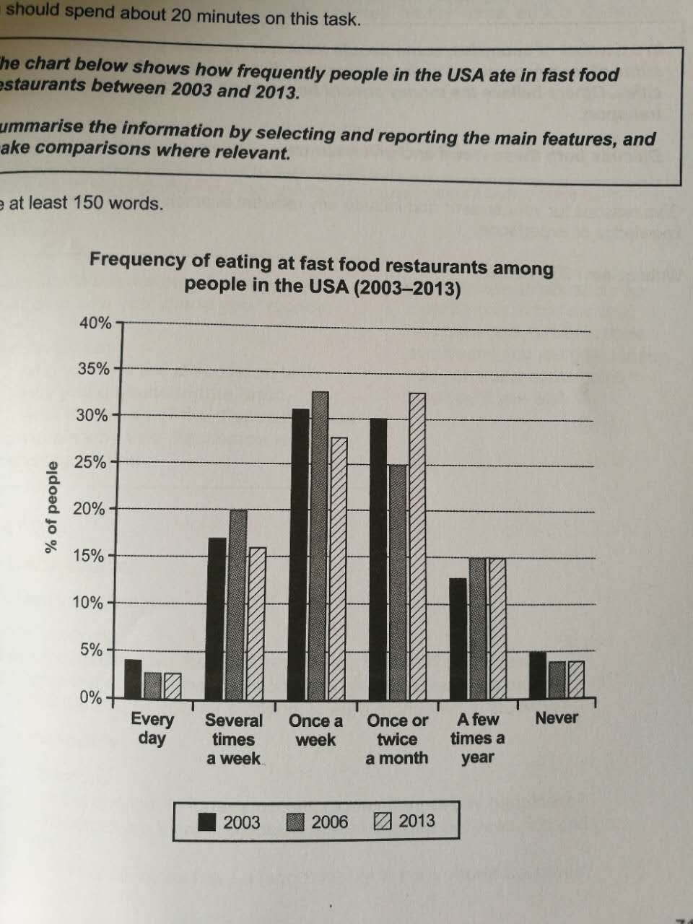

This graph illustrates the frequency of people ate in fast food restaurants from 2003 to 2013.

The percentage of people ate fast food every day or never both dropped about 1% between 2003 and 2006. However, there is a slightly rise from 2003 to 2006 on the amount of people who ate fast food several times a week, once a week or a few times a year. The time between 2003 and 2013 also witnessed a significant drop to 25% and a huge rise to 33% on people who ate once or twice a month after the drop.

At the time of 2003, the percentage of people who ate fast food once a week is the largest, while the least people eat every day. In 2006, the situation is still the same, but in 2013, the group of people who ate once or twice a month had the largest amount.